- Install git.
Already locally installed

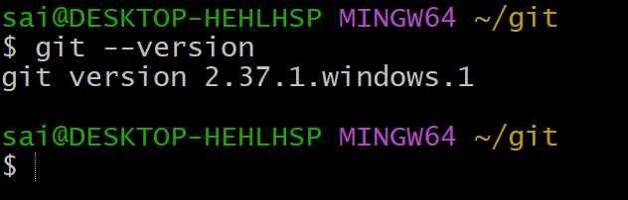
- Create a repo in github with README.md and .ignore file.
The below picture is about how to create repository
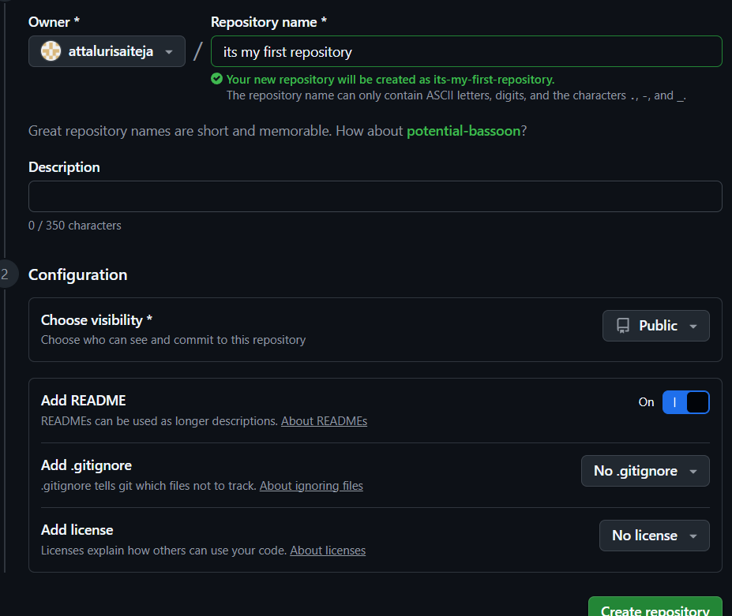

Created another repository with name testing
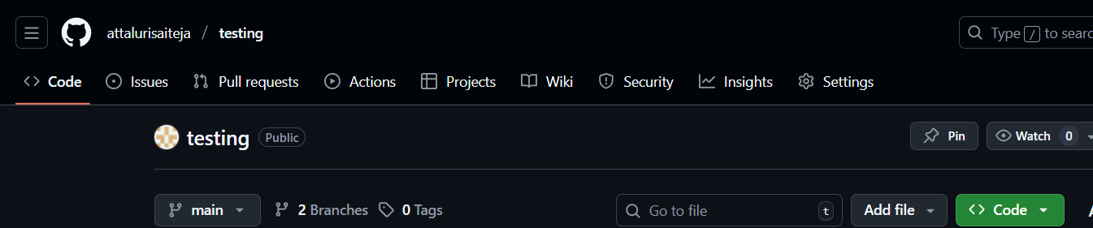
After that added files like .ignore and enabled the README.md file while creating a repository
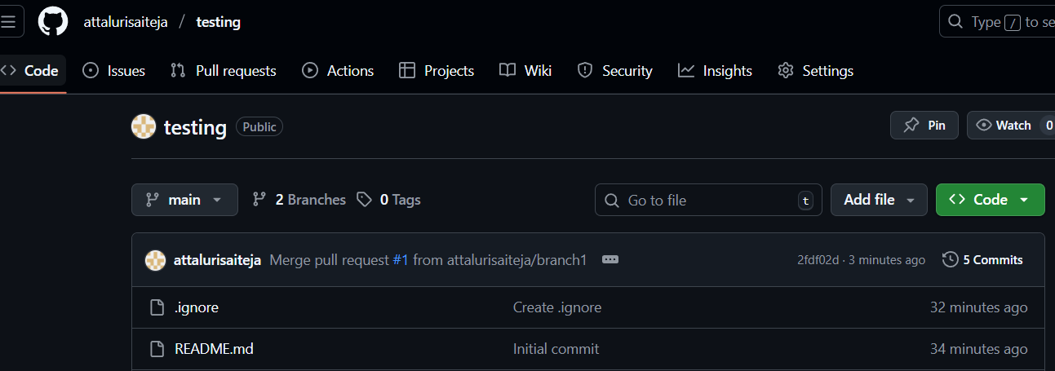
- Clone the created repo to local.
Before using clone at first we need to initialize the git to get git access
Command : git init
We can use command git clone -b main url (ssh link) to download data from repo to local machine
After checked with ls command to verify whether the data is downloaded or not
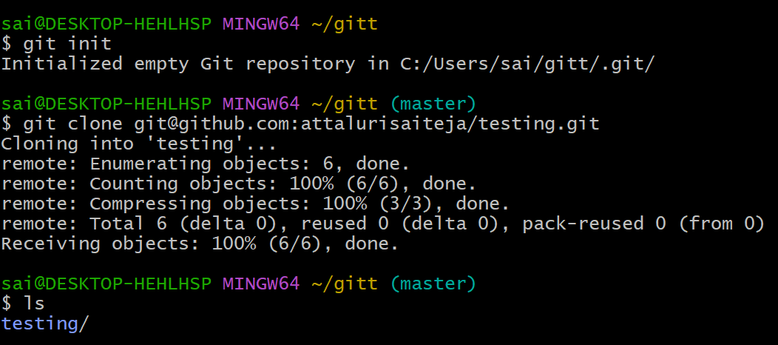
- Create two files in local repo.
Changing the directory to testing/ using cd command
Created 2 files using touch command and listed the files using ls
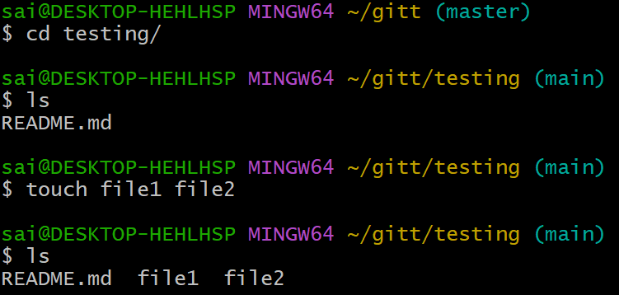

- Commit two files and push to central Repository
Before commiting the files we need to add the files to track (from untrack to track)
And checking status of files either tracked or not using git status command
Committed two files using git commit -m “messages” command
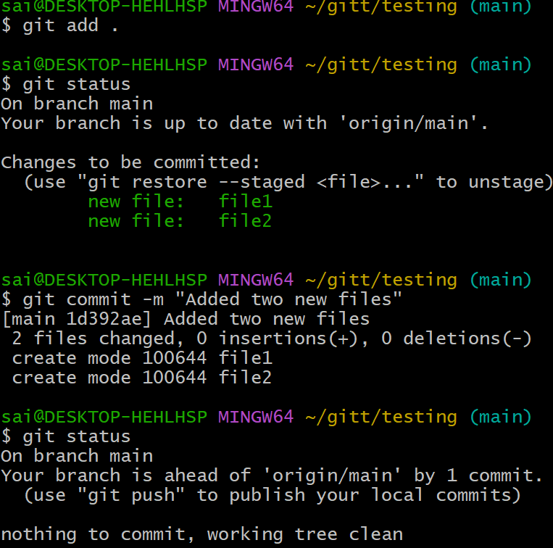
And using git push command I pushed the files from local to central repo and again checked the status
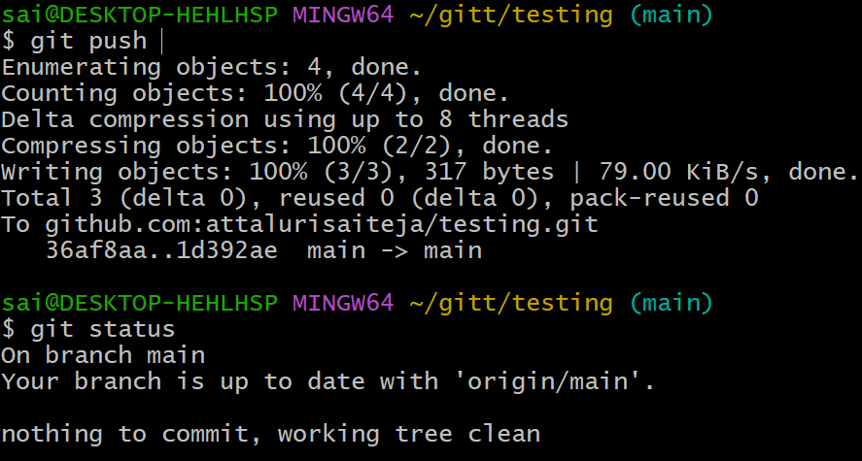
- Create a branch in local and create a sample file and push to central.
Before creating a branch I checked the list of available branches using command git branch –list and the (*) symbol before the branch defines you in which branch you are.
Created a branch in local machine using git branch command and changed the branch using git checkout command and created a sample file using touch command.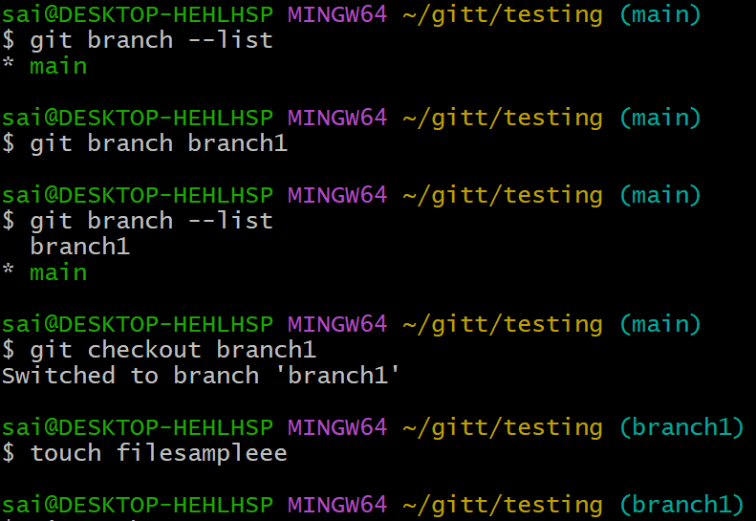
Using git remote add origin ssh link to push the files and use command git remote -v to list the already added links
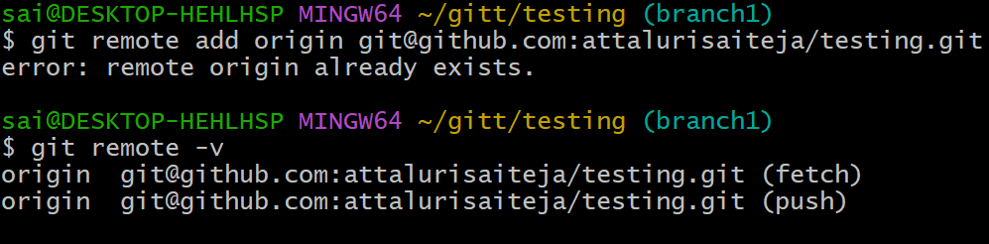

Added the files again and checked the status and added to tracked files using git add . command
After that committed the files using git commit -m “messages” command
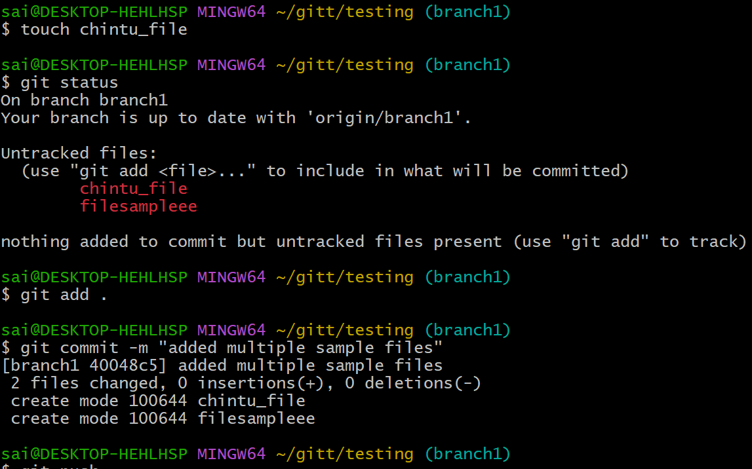
Pushed to central repo using git push command and re verified the status.
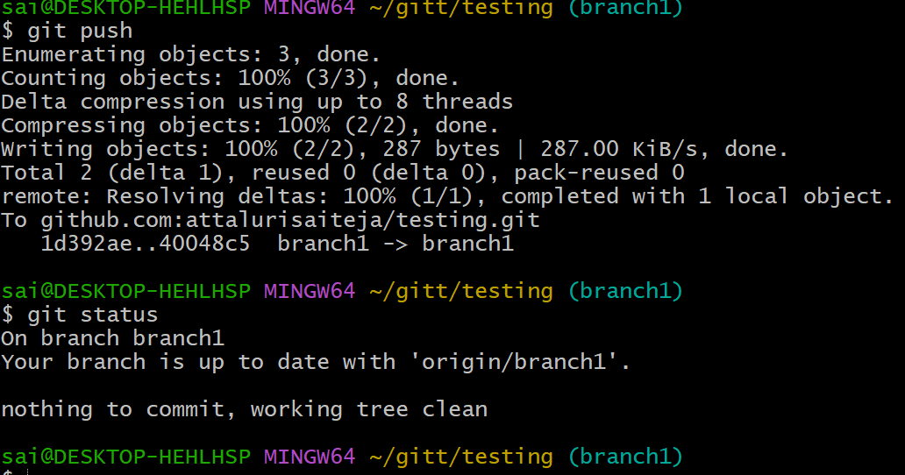

Verified in central repo and you will get a pop up of compare and pull request as seen in below picture
We need to click on compare and pull request and need to verify.
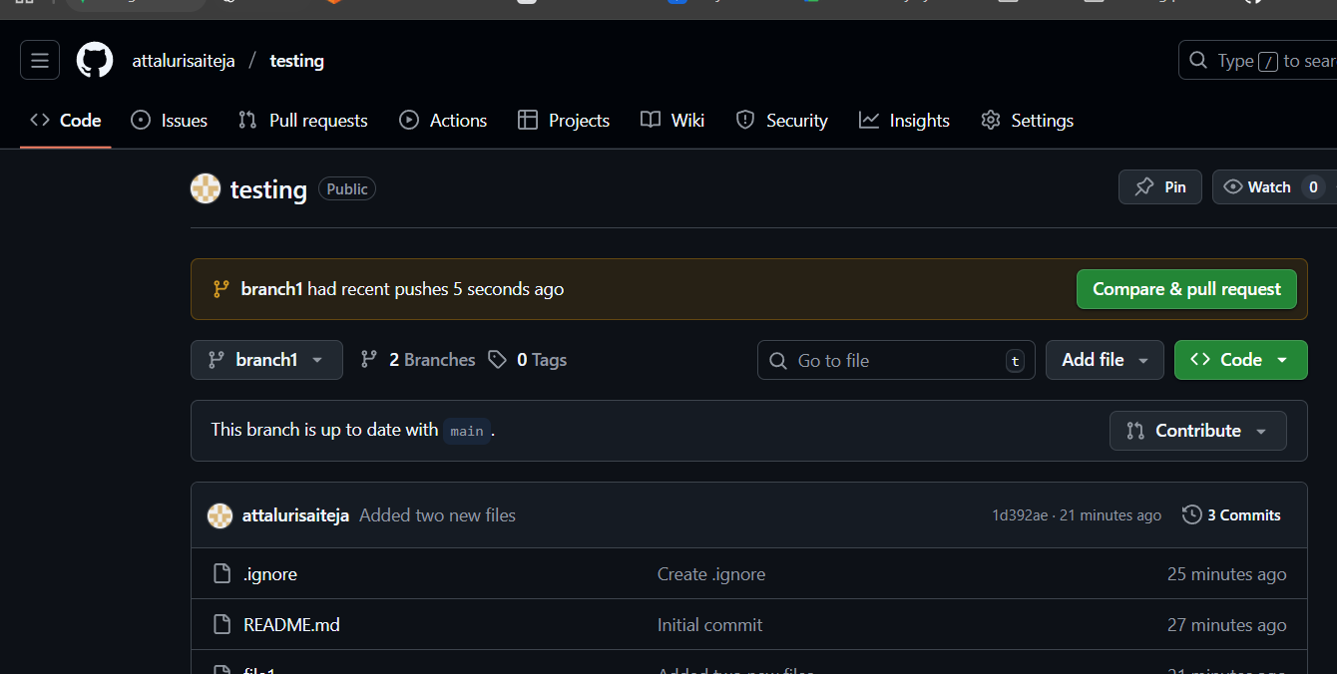
Verifying the files which we pushed from local to central repository.
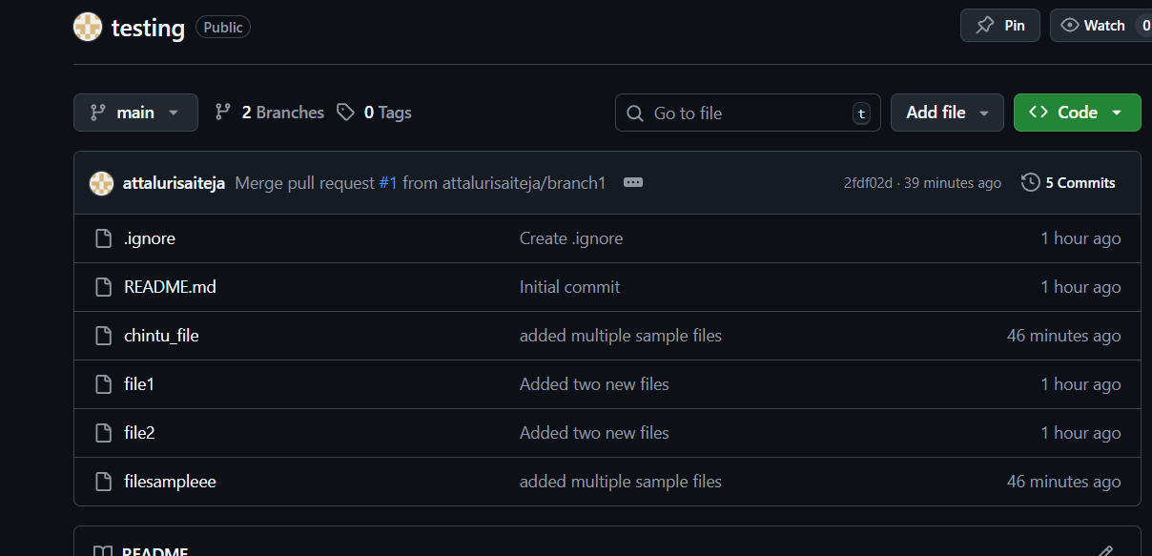

7. Create a branch in github and clone that to local.
Created a new branch in central repo. Click on main branch and enter the name which you need to create and select create
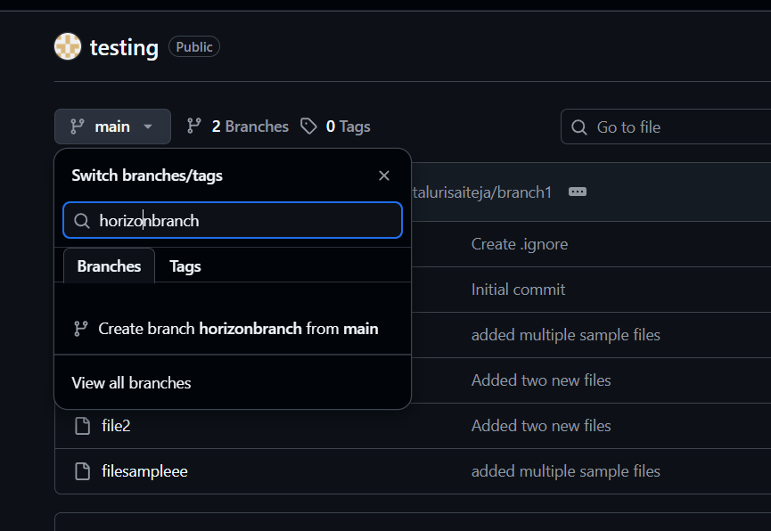
After that horizon_branch has been created and able to see in below picture
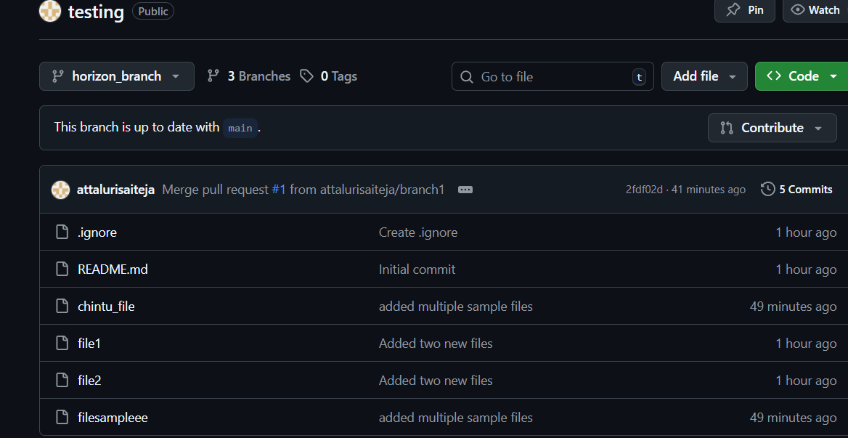

Changed the branch from branch1 to main and listed the available branches using git branch command
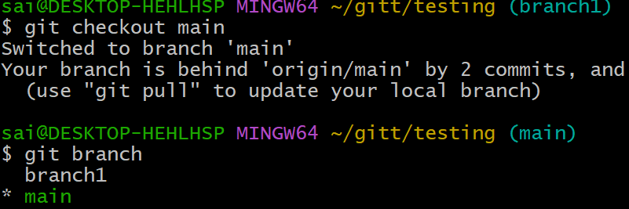
And use git pull command and downloaded the files.
Used git checkout command to switch the branch and listed the branches
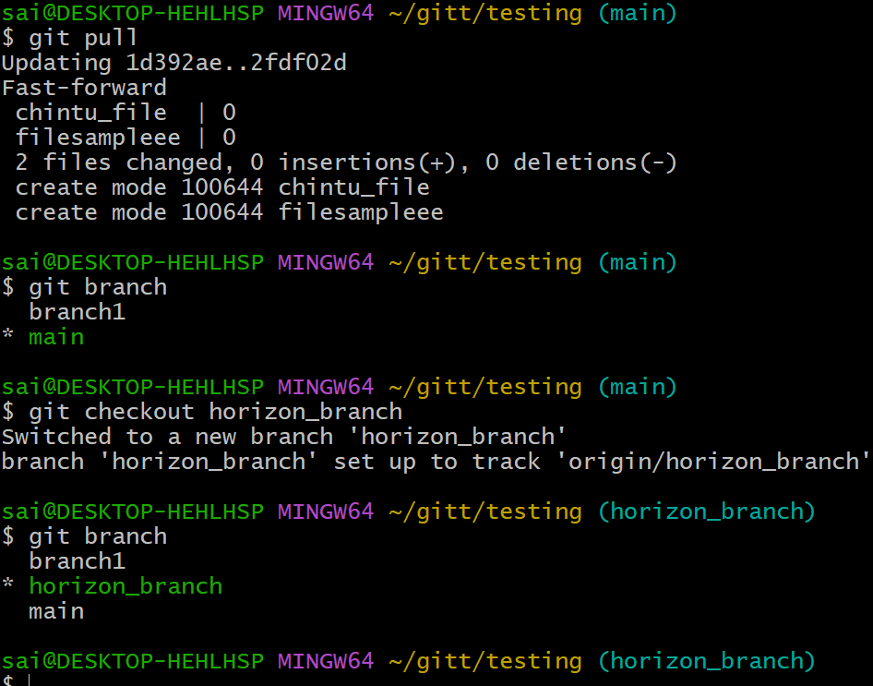

- Merge the created branch with master in git local.
Changed the branch from horion_branch to main branch then applied the command git merge. Command is git merge branch name
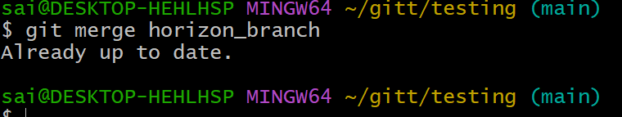

9.Merge the created branch with master in github by sending a pull request.
I have merged the created branch with master by sending apull request and merging them
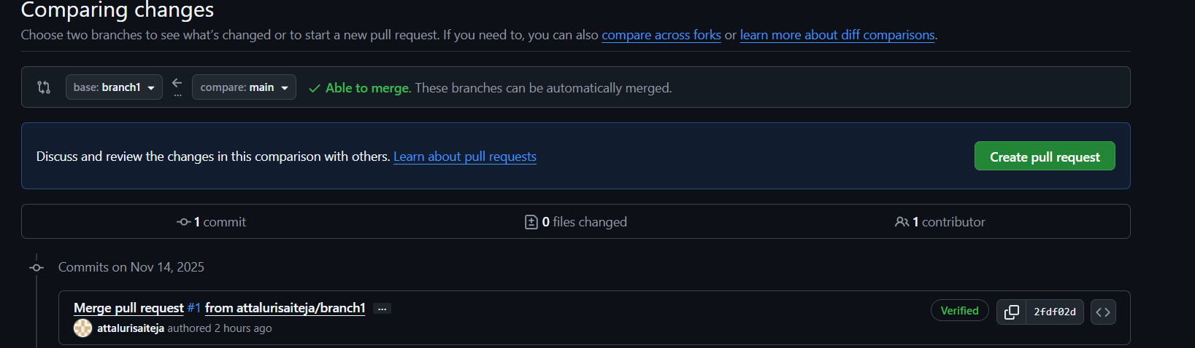
After clicking on pull request we need to verify and submit the merge request. If you nedd you can add some meaningful comments
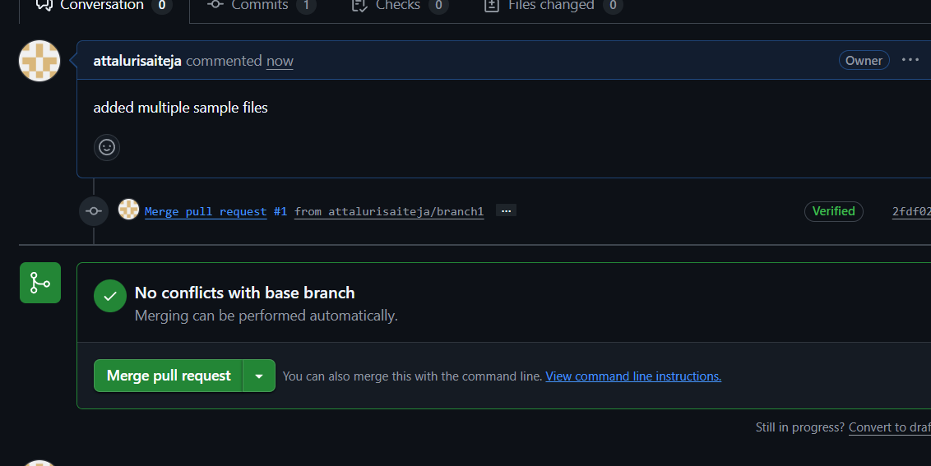

After that we need to click on merge pull request tab and select merge then it will successfully and will closed.


- Create a file in local and send that to branch in github.
Created new files using touch command
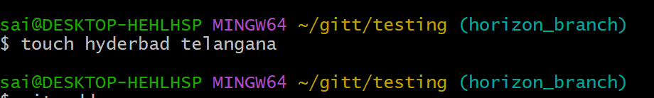
And moved them into tracked files using git add . and checked the status
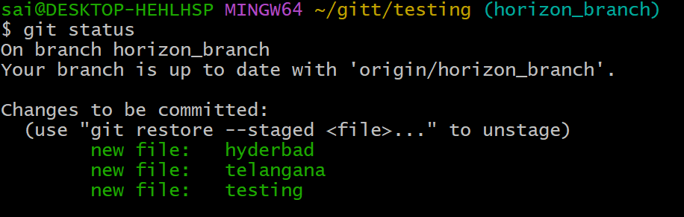committed the files using git commit -m “messages” command
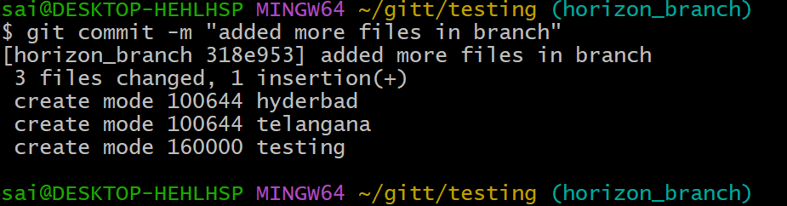

Then after push the files into central repository
Command using git push -u branch name
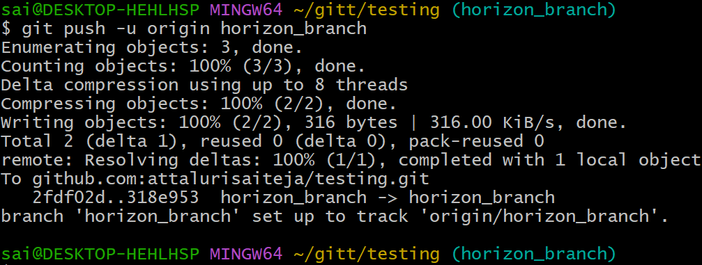
Verifying on github
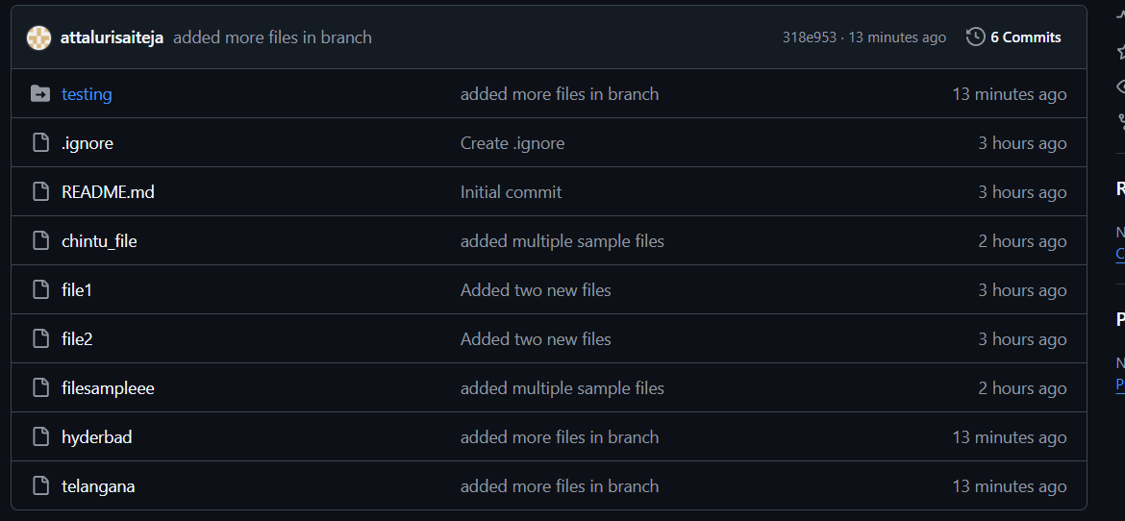

- Clone only a branch from github to local.
I think it already cloned so I have created a new directory and clone a single branch inside it
Using command git clone –branch horizon_branch –single-branch url
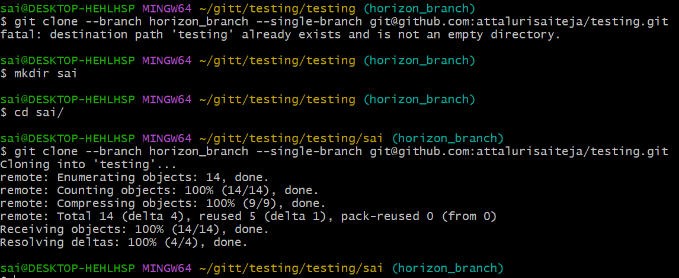
Verified using ls command
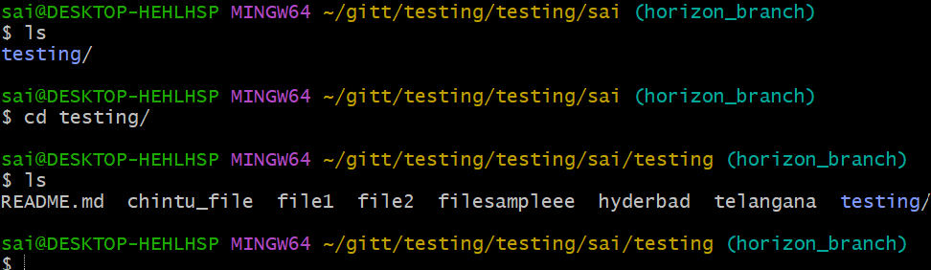
- Create a file with all passwords and make that untrackable with git.
Created new file name called password
Added all the file name which to be ignored to .gitignore with using vi command and inserted the data
And checked the status.
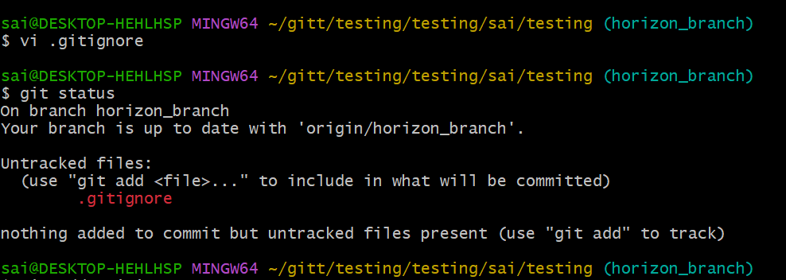
And added the file to track using git add . command
And committed the file using git commit -m “message” command
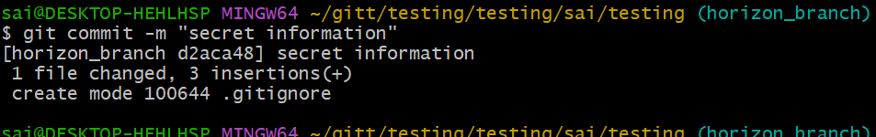

Pushed the file using git push -u origin command
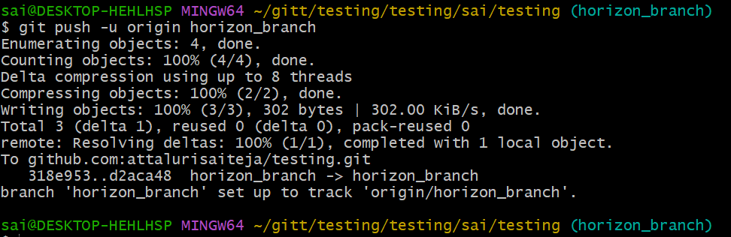
Verified on github central repository
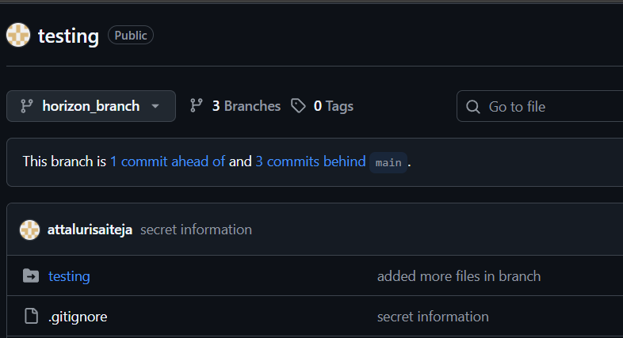
Only file names are displayed and not the information is available inside.
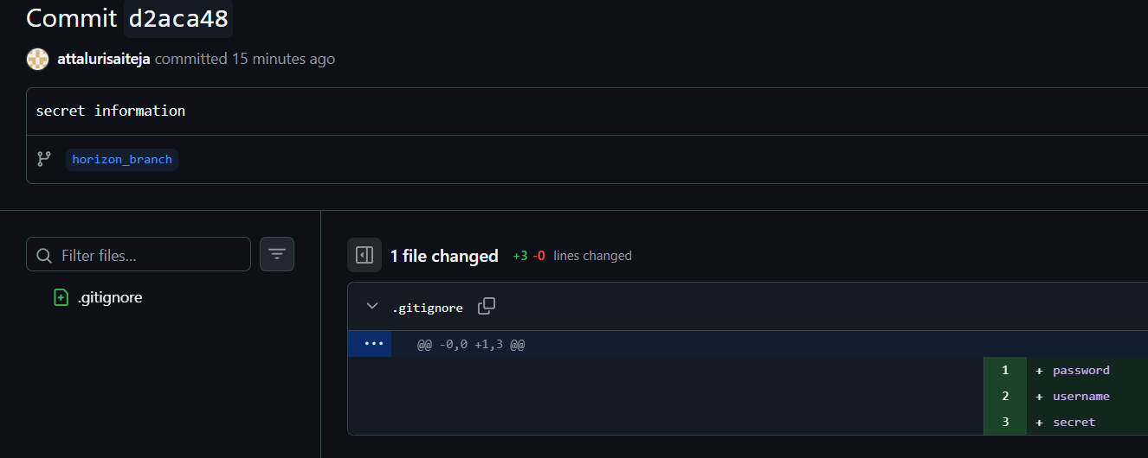

- Revert a commited commit to the older version.
Creating a file using vi and inserted data into it and added to tracked files and committed the files
After that again accessed the file again and using vi changed the data inside the file and done same
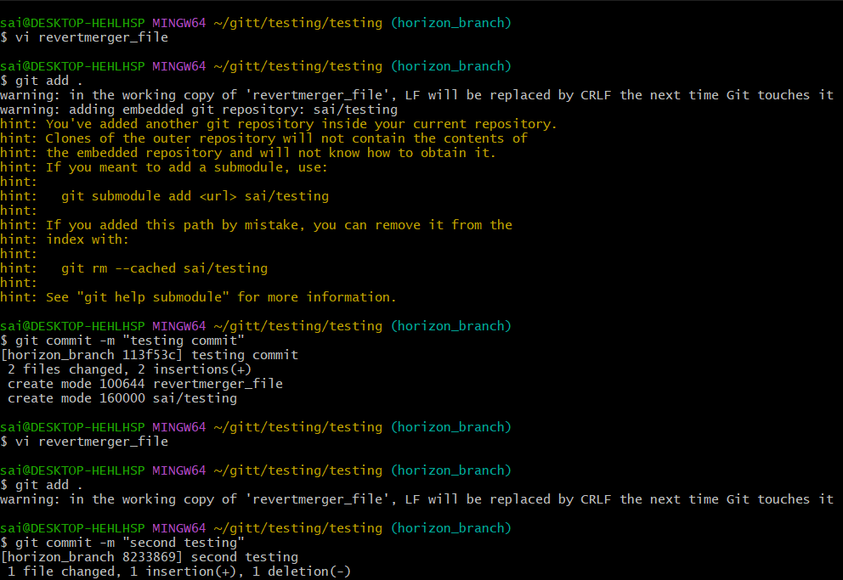

- Make a commit and make that commit reset without savings changes.
Git reset command helps us to revert the commit using or matching commit number
Added a bunch of files using touch
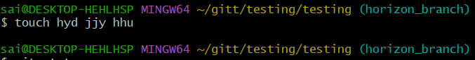
Added to tracked files using git add .
And checked the status using git status
Later applied git reset command to untrack the files
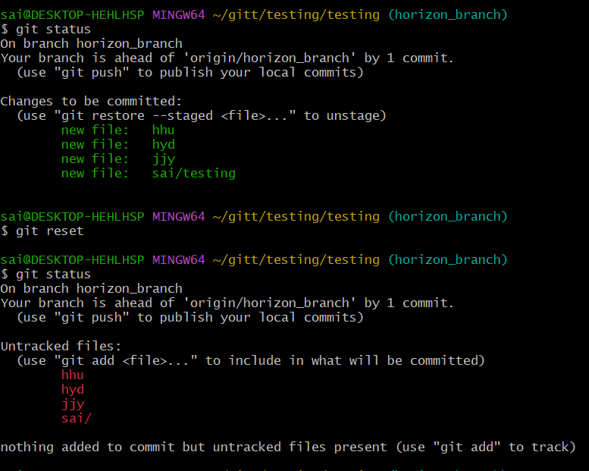

- Push a file to stash without savings the changes and work on another file.
Created a file called gitstash_file using touch and checked the status using git status
And added to tracked files then after
Moved the file to stash memory using git stash command and agaian checked the git status for reverifying in that the file name gitstash_file is not tracked.
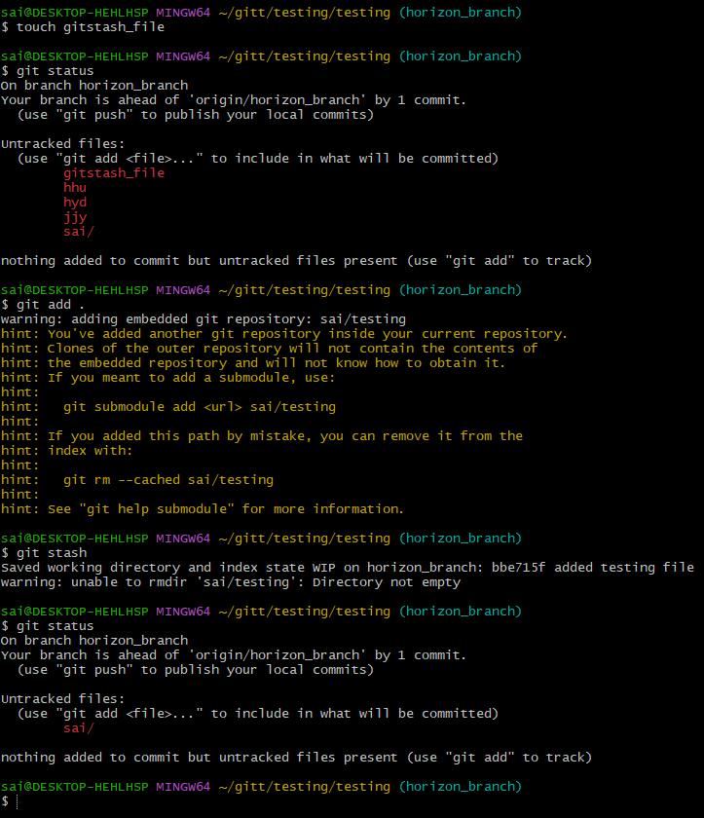

- Undo the stash file and start working on that again.
Using the command git stash list to access how many files are in stash memory.
Using git stash pop command to bring back the file from stash memory to tracked file
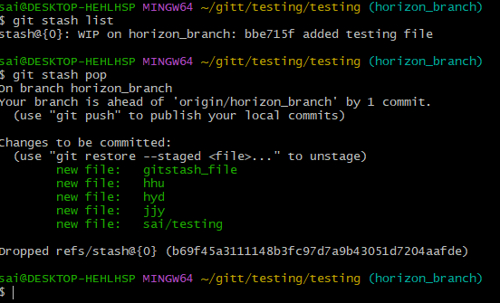

- Generate a ssh-keygen and configure into github.
Generated a secure key using ssh-keygen and copied public key using cat command
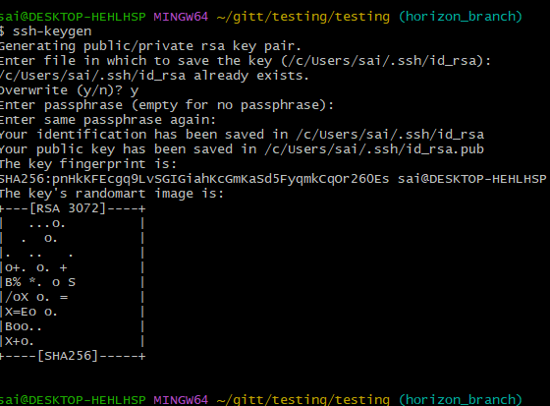
And pasted in github
At settings we can find option to add keys and gpgs
Then we need to select ssh key and paste over there and submit
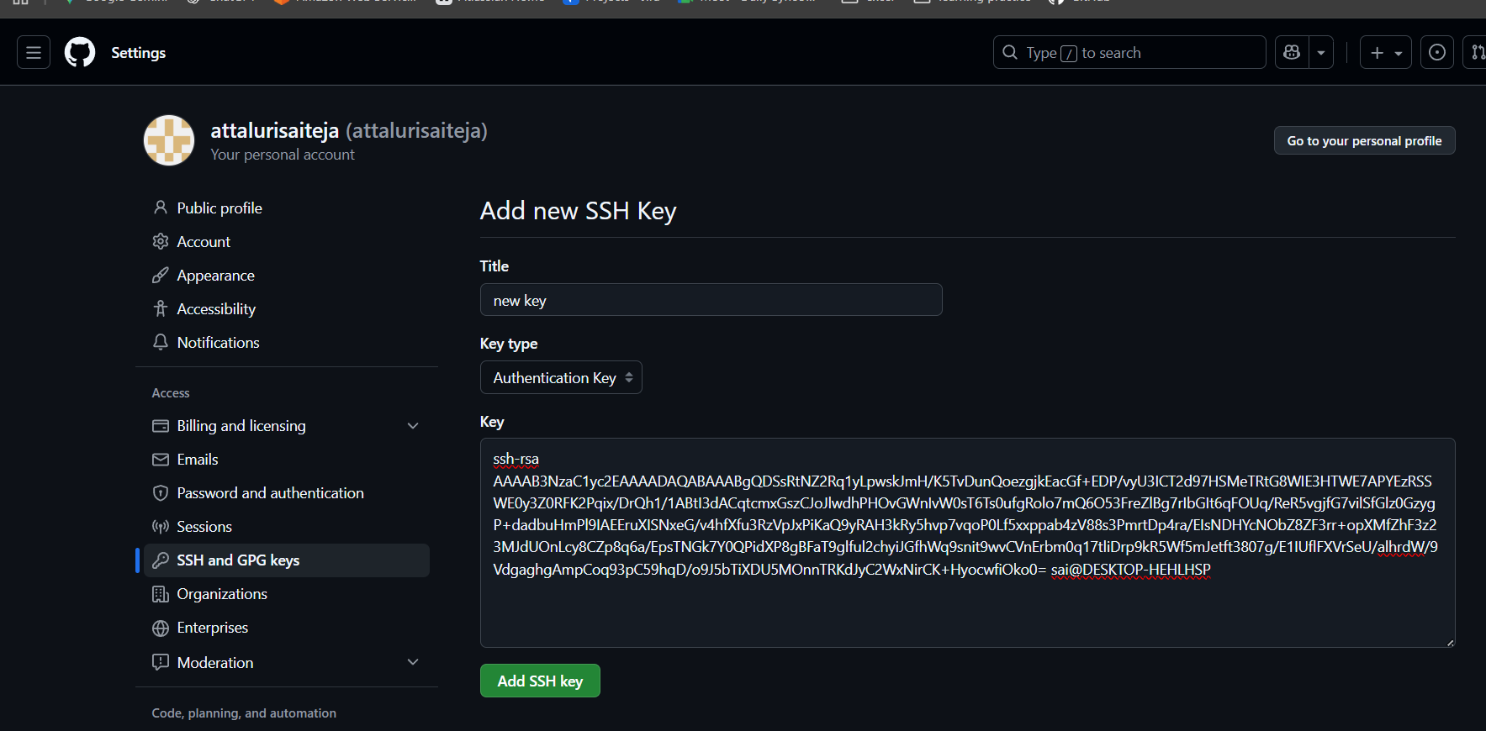
After that you need to confirm the verification process
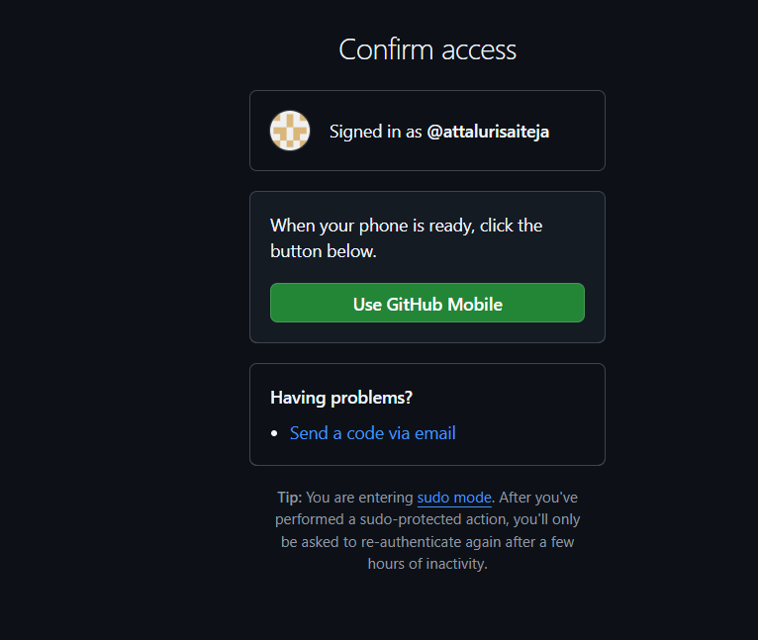
Then it will be added and shows all keys which are available
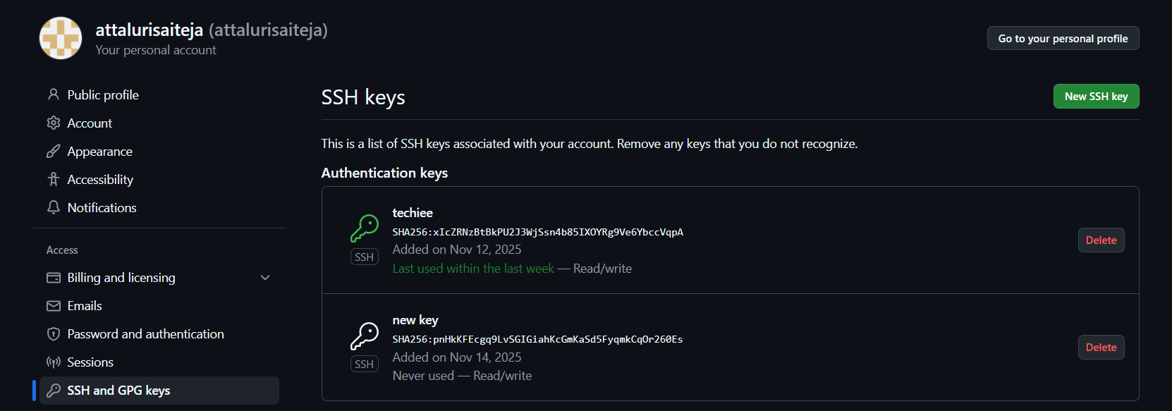
- Basic understanding of .git file.
The .git folder stores everything Git needs to track your project — history, branches, commits, logs, and settings.
Think of it as the brain of your repo.
What’s inside the .git folder? (Simple Explanation)
1️⃣ HEAD
- Points to the branch you are currently on
- Example: refs/heads/main
2️⃣ config
- Repo settings (username, email, remote URLs)
3️⃣ objects/
- Stores all commits, files, and changes in compressed form
- This is your entire commit history.
4️⃣ refs/
- Stores branch pointers like:
  - refs/heads/main
  - refs/heads/horizon_branch
- Also stores tags.
5️⃣ logs/
- Stores your Git activity logs.
6️⃣ index
- Staging area information (git add goes here).

✔ Why is .git important?
Without the .git folder:
- Your project is not a Git repository
- You cannot make commits
- You cannot switch branches
- You cannot push or pull
It’s like your project losing its entire Git history.

⚠️ Important Warning
👉 NEVER delete the .git folder unless you want to remove Git tracking completely.
If you delete it, Git history and branches are gone.
- Check all the logs of git.
To check the logs we use command called git log
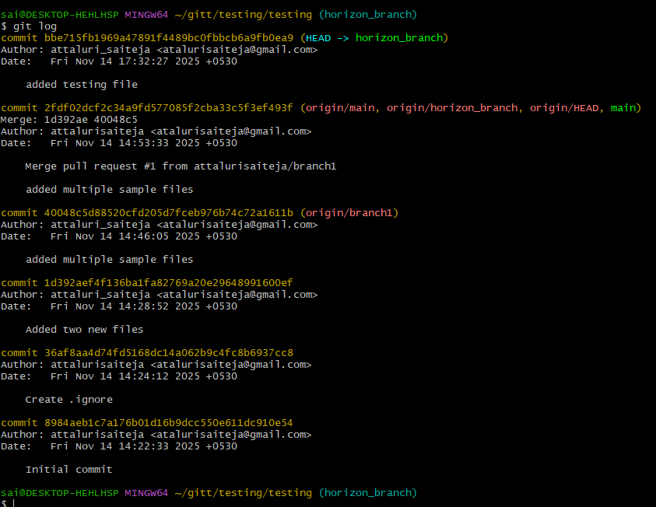

To check all logs we use git log –all command to see full list
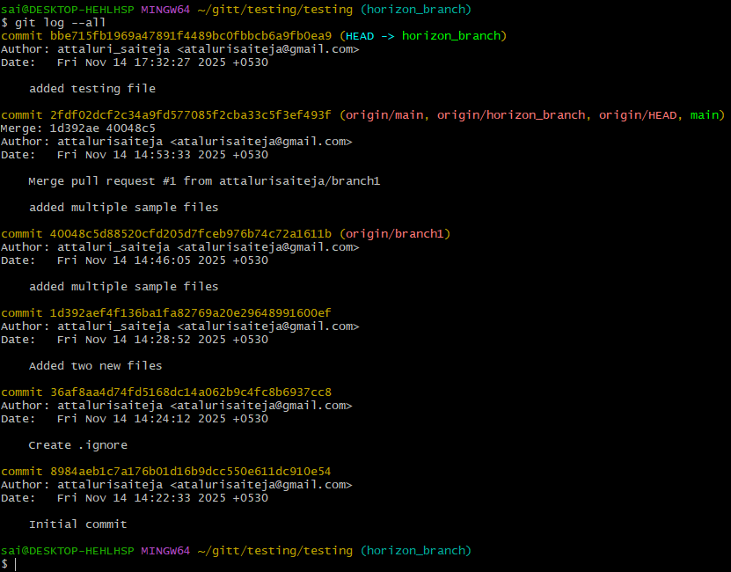

- Rename the commit message.
Use the command git commit –amend -m “new message” to change the commit message previously done.
For older commit use git rebase -i HEAD~3 command to change but it not required to change unless necessary.
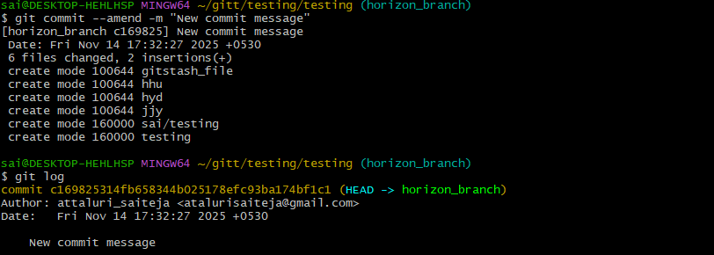
- Merge multiple commits into single commit.
Use command git rebase -i Head~3 to access the file and change the details from pick to squash as seen in below picture by that the commits will merged with other
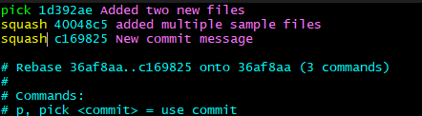
After you will be redirected to below picture confirm and save the file using wq!
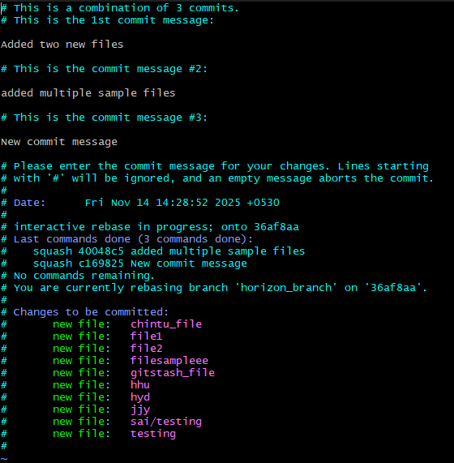

After you will get the output as successful as like below and check the logs to verify
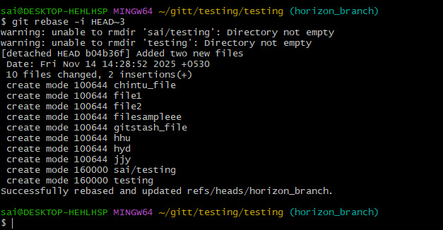
Checking logs using git log command to verify the recently merged commits whether correctly merged or not
